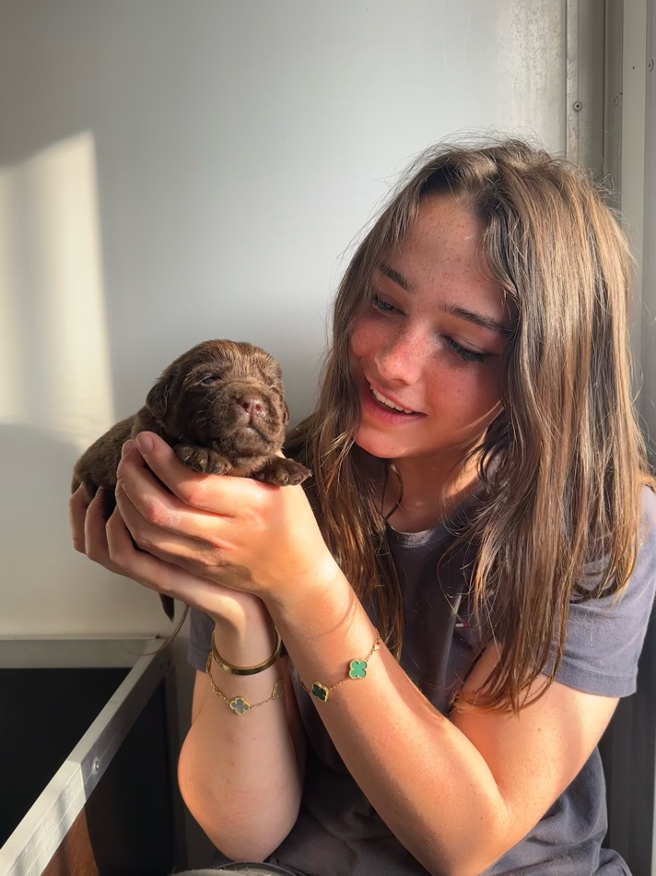
My name is Erin Llewellyn, I live in South Wales and am about to enter my third year of veterinary medicine at Harper & Keele Veterinary School. I enjoy exploring the countryside with my golden retriever, Ffion, and horseriding. I’m hoping to work in a mixed practice once I graduate, but have a particular interest in large animal medicine. Thank you for taking the time to read my poster, I hope you enjoy!

